How flawed constitutions undermine democracy

Michael Albertus and Victor Menaldo

Monkey Cage
February 26, 2018
https://www.washingtonpost.com/news/monkey-cage/wp/2018/02/26/why-so-many-citizens-are-fed-up-with-democracy/

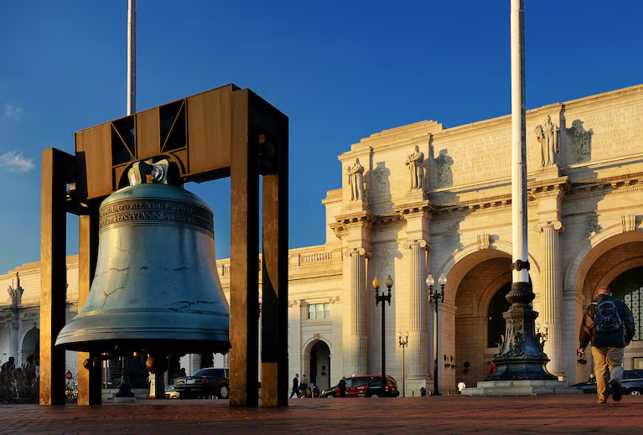
A replica of the Liberty Bell stands in front of Union Station in the District in 2013. (Bill O’Leary/The Washington Post)

Many scholars and pundits have recently declared that democracy is in crisis. According to analyses that draw on data from the Varieties of Democracy Project, the average level of democracy across the world has not necessarily declined. But over the past five years, the quality of democracy has declined in more countries than the number in which it has increased.

Ukraine, Hungary, Turkey, Poland and Venezuela are flirting with authoritarianism. The current U.S. president regularly violates democratic norms: attacking the media, the Justice Department and the FBI when they push back against him. With Donald Trump in office, leaders with authoritarian tendencies in countries such as Egypt and Russia are crushing their political opponents, aware that the U.S. State Department will do nothing more than issue a mild rhetorical rebuke. And recent polling data suggests that a surprising number of Americans would, under the “right” circumstances, support a military takeover of the U.S. government.

How and why is all of this happening?

One theory: Danger grows as informal norms erode

Steven Levitsky and Daniel Ziblatt’s new book, “How Democracies Die,” has rightly received a great deal of attention for outlining steps that lead democracies into authoritarianism. Among the key takeaways: Democracy depends in no small part on citizens’ and the elite’s willingness to tolerate and work with political opponents and to exercise political power with restraint rather than ruthlessness. Informal norms of cooperation and collegiality across differences both complement and ultimately enforce democratic constitutions, they argue; when the political elite begin playing no-holds-barred politics, nations risk slipping toward authoritarianism.

Outgoing authoritarian governments write biased constitutions

But there is still more to consider. In many countries, democratic backsliding comes from far deeper sources. In our new book, “Authoritarianism and the Elite Origins of Democracy,” we document a little-known fact: Out of the 122 total democratic transitions since 1800, in 80 cases — or 66 percent — new democracies inherited a constitution from authoritarian predecessors. That includes some of the world’s early democracies, such as the Netherlands, Belgium, Sweden and Norway. Examples since World War II include Argentina, Chile, Kenya, Mexico, Nigeria, South Africa and South Korea.

Why does that matter? When an outgoing authoritarian regime designs democratic institutions, it often shields the incumbent elite from the rule of law and gives them an unfair advantage in the new democracy’s politics and economy. Those outgoing rulers and incumbents want to protect their own lives and welfare, avoiding accountability for human rights violations and political repression.

We shouldn’t be surprised, then, that some of these biased constitutions contain the seeds of a return to dictatorship. Citizens may be free from censorship and outright repression — but they are not equal and important players in deciding public policy. In these imperfect democracies, opportunistic politicians often try to agitate the masses, urging them to vote out the “corrupt” elite and overturn their “rigged” institutions. Demagogues then use power to ride roughshod over deliberation, consensus building and civil liberties.

How can these biased constitutions be fixed?

Transforming these biased democracies isn’t easy. The constitutions are often hard to change; achieving change requires large supermajorities. The oligarchs and the elite enriching themselves under these constitutions pass policies that entrench their power, such as lax lobbying and campaign spending laws, and rig economic regulations to make it hard for entrepreneurs to compete on a level playing field.

Consider Burma, also known as Myanmar. Yes, the military junta did allow the 2015 elections in which Aung San Suu Kyi and the National League for Democracy took office — but that happened within the military’s 2008 constitution. Before handing over power, the military-dominated legislature passed laws that included amnesty for military generals accused of human rights abuses, a generous pension plan for departing lawmakers, and lucrative business contracts for outgoing generals and others in the elite. What is more, the constitution awards the military 25 percent of the parliament’s seats — the proportion needed to block constitutional reform.

Some demagogues manage to rewrite these constitutions — to their own benefit

Precisely because holdover authoritarian constitutions are so hard to change, things often get ugly when democratically elected leaders try to get rid of elite biases.

Consider Turkey, where in 1982, the outgoing authoritarian government wrote a constitution that governed the 1983 transition to democracy. Some of that constitution’s trap doors included a constitutional court that could ban “extreme” parties, and immunity for generals from prosecution for past human rights abuses. The military and allied oligarchs-maintained control of key industries. Many citizens and clerics resented these privileges and abuses. In the 2000s, Recep Tayyip Erdogan of the Justice and Development Party exploited that resentment to ride into office — and then used populist bluster and a state of emergency to gut the checks and balances and military vetoes that had hemmed in civilian politicians.

But Erdogan has not stopped there. He has conducted a campaign to consolidate the executive branch’s power, jail officers, empower Islamists, purge universities, and enervate individual liberties and the judiciary. In 2017, he won a popular referendum that approved 18 amendments to the constitution, transforming Turkey into a presidential system that gives the executive outsize power.

Or consider Hungary. Its transition to democracy took place within the 1949 communist constitution, although it was heavily amended on the eve of democratization in 1989. Those amendments gave the president significant legal status, created a new constitutional court, protected human rights and established genuine elections with competition. But political transformation remained within the earlier constitution’s legal boundaries, making it easier for the outgoing authoritarians to protect themselves, including securing immunity for past crimes.

As in Turkey, Hungarian citizens resented the special dealings for former authoritarians. For more than 20 years, elected governments tried to amend or overturn the constitution. With that as background, in 2010, the nation elected the far-right political party Fidesz and its leader, Viktor Orban, who became prime minister. The election gave Fidesz a sweeping two-thirds victory that enabled it to form Hungary’s first post-1989 non-coalition government. Fidesz has had the numbers and power to rewrite the unpopular holdover constitution — but it has done so in an illiberal fashion. Orban’s authoritarian tendencies are now eroding Hungarian democracy.

What does this mean for the United States?

Many have been worrying lately about the decline of U.S. democracy, considering not just President Trump’s inflammatory rhetoric and violations of informal norms, but also Senate Republicans’ refusal to hold hearings on President Barack Obama’s Supreme Court nominee, Merrick Garland, and both parties’ use of budgetary rules to pass major legislation in the Senate while avoiding the filibuster.

But the United States has a much stronger institutional architecture undergirding its democracy. It would be difficult to change the Constitution to give a president the powers of a strongman. And the country’s civil society and media remain strong and vigilant.

How can tilted democracies avoid populism and improve democratic quality?

Our book also demonstrates that democracies biased toward an authoritarian-era elite can become more representative and egalitarian — through measured statesmanship and patient, incremental change. Sweden is a great example. While not always politically popular, such an approach is the best bet for flawed democracies that seek to eliminate their worst distortions while avoiding another bout of dictatorship.

Michael Albertus is an assistant professor of political science at the University of Chicago.

Victor Menaldo is an associate professor of political science at the University of Washington.

Together they are the authors of the newly published “Authoritarianism and the Elite Origins of Democracy” (Cambridge University Press, 2018).

